Student Performance Prediction System

Project Id : 2

Name : Anirudh Rana
Class Roll Number : 32
University Roll Number : 2028641
Section and Group : U,G1

Name : Rahul Rawat
Class Roll Number : 19
University Roll Number : 2028470
Section and Group: U,G1

Name : Abhishek Negi
Class Roll Number : 3
University Roll Number : 2028377
Section And Group : U,G1

TABLE OF CONTENTS
- Problem Description 3
  - Dataset Description 3
  - Flow diagram 4
- Modules for Project Implementation…………………..…………………………5
  - Modules Used 5
  - Platform Used 6
- Machine Learning model/ Searching Technique used 7
- Evaluation metrics used 8
- Results and Visualizations 9
- Conclusion and Future Scope 11
- References 12

- Problem Description
Design and develop an end-to-end machine learning classification system to predict loan default using customer banking data. The project should begin with exploratory data analysis (EDA) to understand data distributions, correlations, and patterns, followed by comprehensive data preprocessing including data cleaning, normalization, transformation, and dimensionality reduction using Principal Component Analysis (PCA) to handle high-dimensional data. The system should implement Support Vector Machine (SVM) classifiers using different kernel functions such as linear, polynomial, and radial basis function (RBF) and K-NN. The trained models must be evaluated and compared using standard classification performance metrics including precision, recall, F1-score, and ROC–AUC. The project should demonstrate a complete machine learning pipeline from raw data analysis to model evaluation, emphasizing best practices in preprocessing, model selection, and performance assessment.
  - Dataset Description :

The dataset used in this project is related to loan default prediction. It
contains information about applicants such as their financial and personal
details, which are used to determine whether a loan is likely to be defaulted
or not.

The dataset includes important features such as Annual Income, Loan
Amount, Loan Term (in months), Credit Score, Existing Loans Count,
Debt-to-Income Ratio, and Savings Balance. These features help in
analyzing the financial condition of the applicant.
The target variable in the dataset is loan default status, where:
1 indicates that the applicant is likely to default on the loan
0 indicates that the applicant is not likely to default
The dataset was preprocessed by handling missing values, removing
duplicates, and scaling the features using MinMaxScaler to improve model
performance.

1.2 Flow Diagram

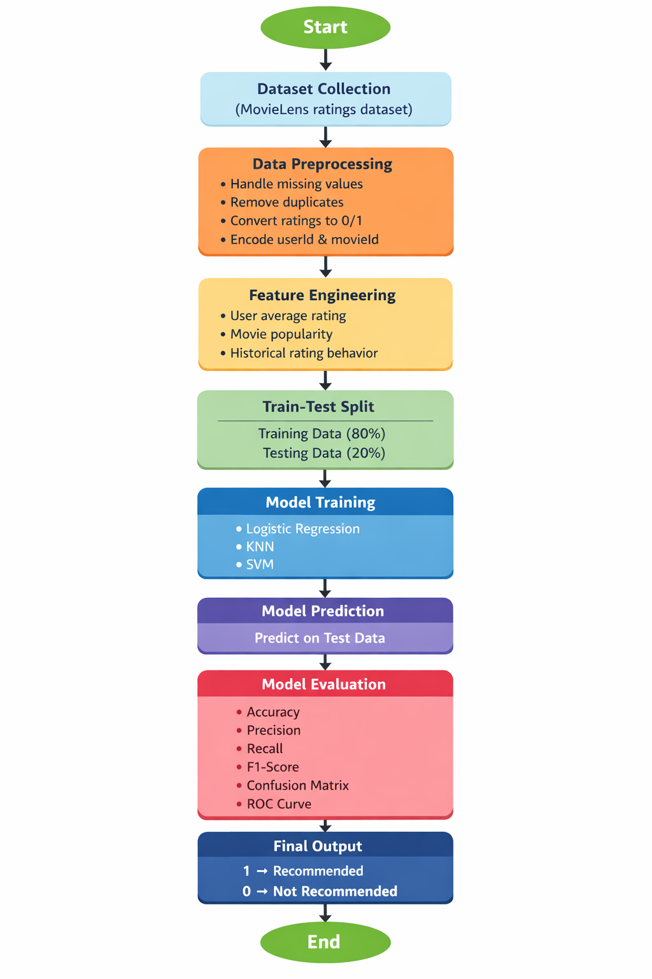
Fig.1 Flow diagram of Loan Default

2. Modules for Project Implementation

2.1 Modules Used :

The following inbuilt libraries were used for implementing the project:

1. Pandas
Pandas is used for data manipulation and analysis.
Functions used:
- pd.read_csv() – to read dataset
- DataFrame() – to create data structure
- df.corr() – to find correlation

2. NumPy
NumPy is used for numerical operations.
Functions used:
- np.array() – to create arrays
- np.reshape() – to reshape data

3. Matplotlib
Matplotlib is used for data visualization.
Functions used:
- plt.plot() – to plot graphs
- plt.bar() – to create bar charts
- plt.show() – to display plots

4. Seaborn
Seaborn is used for advanced visualization.
Functions used:
- sns.heatmap() – to create correlation heatmap

5. Scikit-learn (sklearn)
Scikit-learn is used for machine learning models.
Functions used:
- train_test_split() – to split data
- LogisticRegression() – classification model
- KNeighborsClassifier() – KNN model
- DecisionTreeClassifier() – decision tree model
- RandomForestClassifier() – ensemble model
- SVC() – support vector machine
- accuracy_score() – calculate accuracy
- confusion_matrix() – evaluation

6. Pickle
Pickle is used to save and load trained models.
Functions used:
- pickle.dump() – to save model
- pickle.load() – to load model
- 2.2 Platform Used: (mention all the platforms with the reason of using it)
  - Visual Studio Code: For code writing, testing, and debugging.
VS Code is equipped with multiple extensions, debugger which enhance the development experience.
  - Jupyter: Used for data analysis, visualization, and model building. It allows step-by-step execution of code, making it easier to understand and debug the machine learning process.

3. Machine Learning Model/ Searching Technique Used

In this project, multiple machine learning models were used to predict loan default risk. Hyperparameter tuning was performed using GridSearchCV to improve model performance.

1. Logistic Regression
Logistic Regression is a supervised learning algorithm used for binary classification. It predicts the probability of loan default using a sigmoid function and works well for linearly separable data.

2. K-Nearest Neighbors (KNN)
KNN is a non-parametric algorithm that classifies data based on the majority class of its nearest neighbors. The optimal value of K was selected using hyperparameter tuning.

3. Decision Tree
Decision Tree is a tree-based model that splits data based on feature values. It is easy to interpret and helps in understanding decision rules. Hyperparameters such as max depth and minimum samples were tuned.

4. Random Forest
Random Forest is an ensemble learning method that uses multiple decision trees to improve accuracy and reduce overfitting. It provides better performance compared to a single decision tree.

5. Support Vector Machine (SVM)
SVM is a powerful classification algorithm that finds the optimal hyperplane to separate classes. It works well with high-dimensional data.

6. Hyperparameter Tuning (GridSearchCV)
GridSearchCV was used to find the best parameters for models by testing different combinations. It improves model performance by selecting the optimal parameter values.
4. Evaluation metrics used

I. Accuracy
Accuracy measures the overall correctness of the model.
Formula:
$$Accuracy=\frac{TP+TN}{TP+TN+FP+FN}$$

II. Precision
Precision measures how many predicted positive cases are actually correct.
Formula:
$$Precision=\frac{TP}{TP+FP}$$

III. Recall
Recall measures how many actual positive cases are correctly identified.
Formula:
$$Recall=\frac{TP}{TP+FN}$$

IV. F1-Score
F1-Score is the harmonic mean of precision and recall.
Formula:
$$F1=2×\frac{Precision×Recall}{Precision+Recall}$$

V. Confusion Matrix
Confusion matrix shows model performance in terms of:
- TP (True Positive)
- TN (True Negative)
- FP (False Positive)
- FN (False Negative)
5. Results and Visualizations

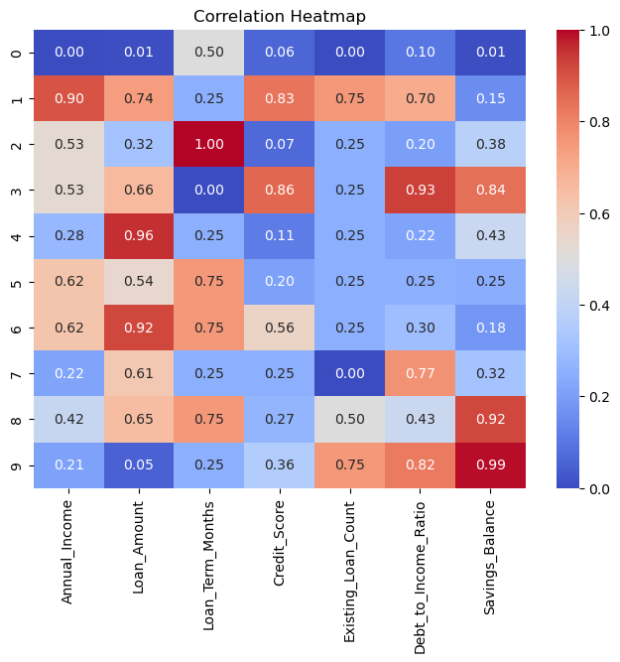

Fig.2 Heatmap showing corelation.

 | Model | Accuracy (%) | Precision | Recall | F1-Score
0 | Decision Tree | 86.0 | 0.901047 | 0.860 | 0.881857
1 | Random Forest | 83.5 | 0.859508 | 0.835 | 0.865306
2 | SVM | 79.5 | 0.796599 | 0.795 | 0.844106
3 | KNN | 73.5 | 0.725889 | 0.735 | 0.809353
Fig3

6. Conclusion and Future Scope:

1

7. References:
Books:
- Let Us Python – Yashavant Kanetkar

Online Resources:
  - GeeksforGeeks – https://www.geeksforgeeks.org/
  - TutorialsPoint – https://www.tutorialspoint.com/cprogramming/index.htm
  - Stack Overflow – https://stackoverflow.com

